**Narrogin Senior High School**

**Strathalbyn Christian College**

**Semester 1 Examination, 2018**

**Source Analysis Booklet**

**ATAR MODERN HISTORY**

**Unit 4**

|  |  |  |
| --- | --- | --- |
| **Document Set** | **Area of Study** | **Related Question** |
| 1 | The changing European world since 1945 | 1  parts (a) – (e) |
| 2 | The changing European world since 1945 | 1  parts (a) – (e) |

**DOCUMENT BOOKLET**

**DOCUMENT SET 1**

**The changing European world since 1945**

**Source 1**

*(Extract from a letter by Nikita Khrushchev to John F. Kennedy, October 26th, 1962)*

Dear Mr. President:

It is with great satisfaction that I studied your reply to Mr. U Thant on the adoption of measures in order to avoid contact by our ships and thus avoid irreparable fatal consequences. This reasonable step on your part persuades me that you are showing solicitude for the preservation of peace, and I note this with satisfaction.

I have already said that the only concern of our people and government and myself personally as chairman of the Council of Ministers is to develop our country and have it hold a worthy place among all people of the world in economic competition, advance of culture and arts, and most necessary field for competition which will only benefit both the winner and loser, because this benefit is peace and an increase in the facilities by means of which man lives and obtains pleasure.

In your statement, you said that the main aim lies not only in reaching an agreement and adopting measures to avert contact of our ships, and consequently, a deepening of the crisis, which because of this contact can spark off the fire of military conflict after which any talks would be superfluous because other forces and other laws would begin to operate - the laws of war. …………..Our purpose has been and is to help Cuba, and no one can challenge the humanity of our motives aimed at allowing Cuba to live peacefully and develop as its people desire. You want to relieve your country from danger and this is understandable. However, Cuba also wants this. All countries want to relieve your country from danger. But how can we the Soviet Union and our government, assess your action which, in effect, means that you have surrounded the Soviet Union with military bases, surrounded our allies with military bases, set up military bases literally around our country, and stationed your rocket weapons at them? This is no secret. High-placed American officials demonstratively declare this. Your rockets are stationed in Britain and in Italy and pointed at us. Your rockets are stationed in Turkey……………………….

Respectfully yours,

Nikita Khrushchev

**Source 2**

**Title: The Cupid of the “New Reality” (1968)**

*Main Characters: Leonid Brezhnev (U.S.S.R), President Lyndon Johnson (U.S.A.), Chairman Mao Zedong (China), Cupid: Canadian PM Pierre Trudeau*

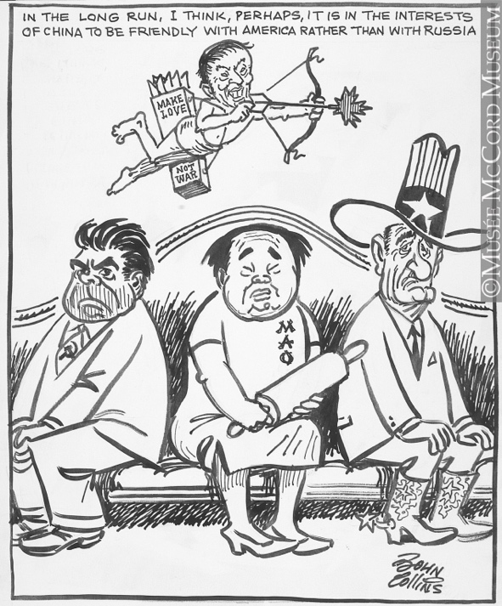

**Source 3**

**1989 changed the world. But where now for Europe?**

By Timothy Garton Ash, The Guardian, 5 November, 2009

Nineteen eighty-nine was the biggest year in world history since 1945. In international politics, 1989 changed everything. It led to the end of communism in Europe, of the Soviet Union, the cold war and the short 20th century. It opened the door to German unification, a historically unprecedented [European Union](http://www.theguardian.com/world/eu) stretching from Lisbon to Tallinn, the enlargement of Nato, two decades of American supremacy, globalisation, and the rise of Asia. The one thing it did not change was human nature.

In 1989, Europeans proposed a new model of non-violent, velvet revolution, challenging the violent example of 1789, which for two centuries had been what most people thought of as "revolution". Instead of Jacobins and the guillotine, they offered people power and negotiations at a round table.

With [Mikhail Gorbachev](http://www.theguardian.com/commentisfree/2009/oct/30/1989-capitalism-in-crisis-perestroika)'s breathtaking renunciation of the use of force (a luminous example of the importance of the individual in history), a nuclear-armed empire that had seemed to many Europeans as enduring and impregnable as the Alps, not least because it possessed those weapons of total annihilation, just softly and suddenly vanished. But then, as if this were all somehow too good to be true, 1989 also brought us Ayatollah Khomeini's [fatwa on Salman Rushdie](http://www.theguardian.com/books/2009/jan/11/salman-rushdie-satanic-verses) – firing the starting gun for another long struggle in Europe, even before the last one was really over.

Such years come only once or twice in a long lifetime. 2001, the year of the 9/11 terrorist attacks, was another big one, of course, above all because it transformed the priorities of the US in the world, but it did not change as much as 1989 did. As the Cold War had affected even the smallest African state, making it a potential pawn in the great chess game between east and west, so the end of the Cold War affected everyone too. And places like Afghanistan were forgotten, neglected by Washington since they no longer mattered in a global contest with the now ex-Soviet Union. The Mujahideen had done his work; the Mujahideen could go. Except that a Mujahideen called Osama bin Laden had other ideas.

The epicentre of 1989 was Europe between the Rhine and the Urals, and it's there that most has changed. Every single one of Poland's neighbours today is new, different from what it was in 1989. In fact, many of the states and quite a few of the frontiers in eastern [Europe](http://www.theguardian.com/world/europe-news) are now more recent than those in Africa. And the lived experience of every man, woman and child has been transformed out of all recognition: nowhere more so than in the former German Democratic Republic, whose death warrant was written 20 years ago next Monday night, with the breaching of the Berlin wall.

So, closest to the ground, we have the stories of those individual human lives: of the young Czechs, Hungarians and East Germans, born in 1989, who are seizing and enjoying the chances of freedom, and of the many older, less well-placed people, who have had a rough time since, and are angry and disillusioned.



At the other extreme, we have the global dance of old and new superpowers. Potentially, there are now three of them: the US, China and the EU. The US is still the only genuine, three-dimensional superpower. When former Presidents Gorbachev and George H W Bush got together with former Chancellor Helmut Kohl in Berlin last week, Bush senior paid fulsome tribute to his friend "Mikhail". He could afford to be generous; after all, America won………….

So, 20 years on, the question before us Europeans is this: can we recapture some of the strategic boldness and historical imagination of 1989? Or shall we now leave it to others to shape the world, while we snuggle down, Hobbit-like, in our national holes, and pretend there are no giants yomping overhead?

**Source 4**

**MILESTONES: 1945–1952**

**North Atlantic Treaty Organization (NATO), 1949 (**Office of the Historian, Bureau of Public Affairs, [United States Department of State](http://www.state.gov/), 2016)

NATO was the first peacetime military alliance the United States entered into outside of the Western Hemisphere. After the destruction of the Second World War, the nations of Europe struggled to rebuild their economies and ensure their security. The former required a massive influx of aid to help the war-torn landscapes re-establish industries and produce food, and the latter required assurances against a resurgent Germany or incursions from the Soviet Union. The United States viewed an economically strong, rearmed, and integrated Europe as vital to the prevention of communist expansion across the continent. As a result, Secretary of State George Marshall proposed a program of large-scale economic aid to Europe. The resulting European Recovery Program, or Marshall Plan, not only facilitated European economic integration but promoted the idea of shared interests and cooperation between the United States and Europe. Soviet refusal either to participate in the Marshall Plan or to allow its satellite states in Eastern Europe to accept the economic assistance helped to reinforce the growing division between east and west in Europe.

In 1947–1948, a series of events caused the nations of Western Europe to become concerned about their physical and political security and the United States to become more closely involved with European affairs………The Western European countries were willing to consider a collective security solution. In response to increasing tensions and security concerns, representatives of several countries of Western Europe gathered together to create a military alliance. Great Britain, France, Belgium, the Netherlands and Luxembourg signed the Brussels Treaty in March, 1948. Their treaty provided collective defense; if any one of these nations was attacked, the others were bound to help defend it………….

**END OF DOCUMENT SET**

**DOCUMENT SET 2**

**Source 1**

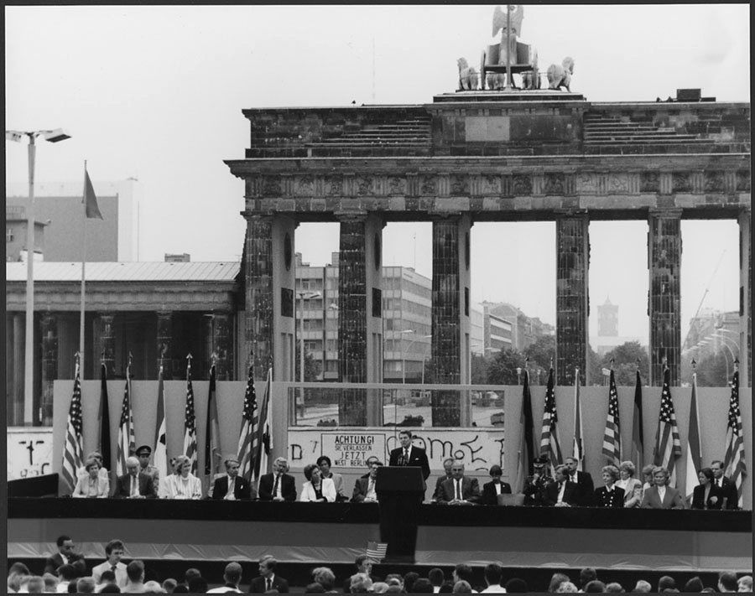

President Ronald Reagan speaking at the Brandenburg Gate on June 12, 1987.

**Source 2**

The entire leadership of the Communist Party in Czechoslovakia has resigned to make way for democratic changes.

Party Leader Milos Jakes called an emergency meeting of his government this morning after admitting to underestimating the force of the pro-democracy movement. Twenty-four members of the Politburo and the Secretariat stood down - mainly the same hardliners who called in the Soviet tanks in 1968 to crush the "Prague Spring" reformers. And the hero of that movement, Alexander Dubcek, has returned from exile to a triumphant welcome in Prague.

He [Mr Dubcek] told a jubilant crowd of 250,000 people in Wenceslas Square: "My idea of socialism with a human face is living with a new generation". He also said the new Civic Reform - the broad coalition of opposition groups formed only a few days ago - represented "all the people".

Pressure on members of the Czech Communist Party had been building for months as they found themselves increasingly out of step with other Warsaw Pact countries and their own people. Two weeks ago, the change sweeping Europe resulted in the breaching of the continent's most potent symbol of the West-East divide - the Berlin Wall.

Even the Kremlin - led by reforming President Mikhail Gorbachev - has indicated it wished to see change in Czechoslovakia.

BBC. (2008). *1989 New era for Czechoslovakia*.

**Source 3**  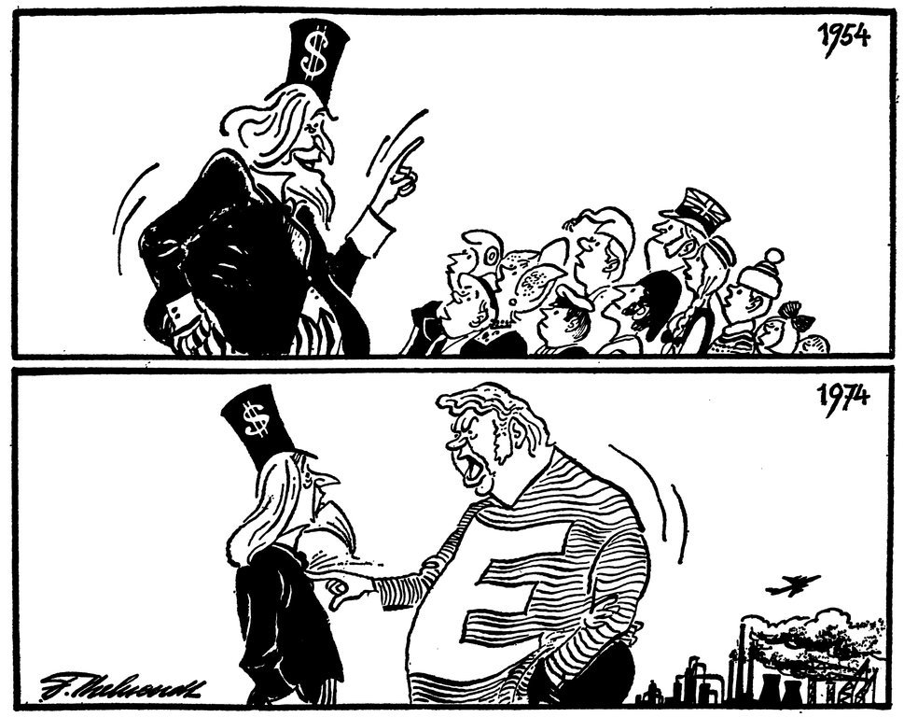

**Source 4**

Surprisingly, the fall of the Berlin Wall on November 9, 1989, turned out to be the biggest challenge to Europe since the fall of Hitler’s Third Reich in the same city on May 8, 1945. Instead of rejoicing about the end of Europe’s division in happy anticipation of European unification under the banner of freedom, democracy and market economy, skeptical concern, fear and immobility soon filled the air. With German unification imminent as the immediate consequence of the fall of the Berlin Wall, even the very rationale of European integration seemed to have become questionable. Germany might not need European integration any longer, some argued. Other notorious skeptics perceived united Germany as the dominating European power, while some analysts were questioning whether or not Germany would maintain its interest in pursuing European integration at all. ... At all times during this decade [1989-1998], Kohl’s government remained unwavering in its commitment to European integration. German unification and European unity were considered as two intrinsically linked sides of the same coin.

**REFERENCES**

**Document Set One: The changing European world since 1945**

**Source 1** AJ Software & Multimedia. (2015). *Khrushchev to Kennedy October 26, 1962*. Retrieved June 6, 2016, from atomicarchive.com: http://www.atomicarchive.com/Docs/Cuba/khrushchevletter2.shtml

**Source 2** Alvarado History. (1968). The Cupid of the “New Reality” (1968). *COLD WAR POLITICAL CARTOONS* http://www.alvaradohistory.com/yahoo_site_admin/assets/docs/Chapter_26_and_27_cold_war_cartoons.9090806.pdf.

**Source 3** Garton, T. (2009, November 5). 1989 changed the world. But where now for Europe. *The Guardian*. London, England: *The Guardian*.

**Source 4** Office of the Historian, Bureau of Public Affairs. (2016). *North Atlantic Treaty Organization (NATO), 1949*. (U. S. State, Producer) Retrieved June 6, 2016, from MILESTONES: 1945–1952: <https://history.state.gov/milestones/1945-1952/nato>

**Document Set Two: The changing European world since 1945**

**Source 1** “Tear down this wall”. *Prologue Magazine*, Summer 2007, Vol. 39, No. 2  
Retrieved from [https://www.archives.gov/publications/prologue/2007/  
summer/berlin.html](https://www.archives.gov/publications/prologue/2007/summer/berlin.html)

**Source 2** ‘On this day 24 November”. (2008). *BBC.* Retrieved from http://news.bbc.co.uk/  
onthisday/hi/dates/stories/november/24/newsid_2546000/2546883.stm

**Source 3** Behrendt, F. (1974). *Cartoon by Behrendt on the changing relations between Europe and the United States (20 March 1974)*. Retrieved May, 2016, from [www.cvce.eu/en/obj/cartoon_by_behrendt_on_the_changing_relations _between_europe_and_the_united_states_20_march_1974-en- fdbe2469-39c1-45e0-8eac-a53928c303b6.html](http://www.cvce.eu/en/obj/cartoon_by_behrendt_on_the_changing_relations%20_between_europe_and_the_united_states_20_march_1974-en-%20fdbe2469-39c1-45e0-8eac-a53928c303b6.html)

**Source 4** Kühnhardt, L. (2009). The Fall of the Berlin Wall and European Integration. Retrieved from <http://www.kas.de/upload/Publikationen/Panorama/2009/1/kuehnhardt.pdf>